Driver Drowsiness Detection using time lapse images by Deep Learning Approach

Malathi Eswaran
Department of Computer Technology-PG
Kongu Engineering College
Erode, India
malathi.ctpg@kongu.ac.in Nandhini V Department of Computer Technology – PG Kongu Engineering College Erode, India nandhiniveera6@gmail.com

Abstract - Drowsiness exists as a transitional phase between wakefulness and sleep, where practically little can be observed or analyzed about a conductor. One of the main factors contributing to the high accident rate is driver weariness, which causes a loss of focus. An attempt has been made in this study to use face parameters that are derived using facial points to determine the condition of tiredness. Also extracted the characteristics of mouth and ocular organs. When compared to several cutting-edge algorithms, deep neural networks perform better. Therefore, the estimation of a driver's degree of sleepiness is thought to be possible using Recurrent Neural Networks (RNNs) along with Long Short-Term Memory (LSTM). They suit well for sequentially processing multimedia data. The suggested method has an accuracy of 97.25%.

Keywords - Computer vision, detecting driver drowsiness, eye featuring, recognizing faces, deep learning, long-short term memory, and recurrent neural networks.

INTRODUCTION
Every year, there is an increasing number of vehicle accidents resulting in injuries and fatalities. Most of them are the result of inattentive driving, speeding, and driver fatigue. The bulk of the automotive sectors are concentrating on one critical element, which is driver sleepiness. It is extremely dangerous to drive when sleepy, and it can be difficult to recognize the signs of sleepiness. Road visibility, inattentive driving, intoxication, weather, and other factors can all contribute to traffic accidents. Most traffic accidents are caused by alcohol drinking. By contrast, the second major reason is tiredness among drivers. Various measures can be implemented, and there are currently advanced tools available to monitor alcohol consumption. while some high-end car brands offer driver drowsiness alerts, this technology is often missing in more affordable vehicles. This creates a gap in safety, leaving many drivers unprotected from the dangers of fatigue. This information is particularly concerning as even a brief moment of drowsiness can have catastrophic consequences. In just a second, a driver's reaction time can be significantly slowed, increasing the risk of accidents, lane departures, and even crossing borders unintentionally.

Therefore, there's a strong need for a more accessible and sophisticated drowsiness detection system. Such a system should utilize both facial cues and driving behavior analysis to accurately assess a driver's alertness. Providing timely warnings, it could empower drivers to take breaks before drowsiness compromises their safety and the safety of others on the road. Driver fatigue, often caused by inadequate sleep and extended periods behind the wheel, significantly increases the risk of fatal accidents.

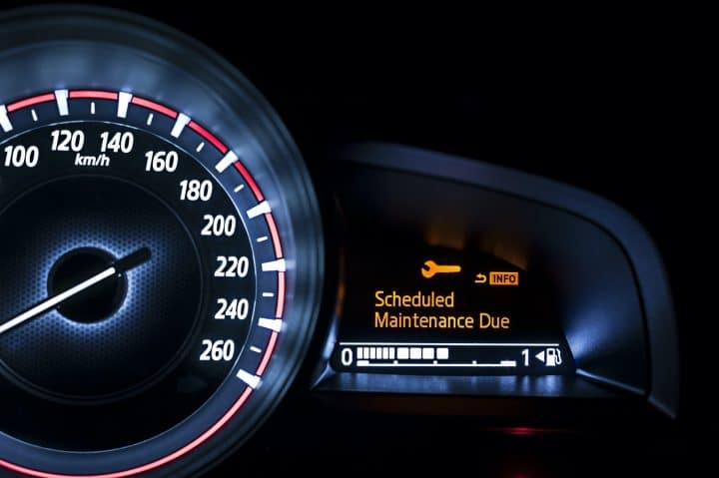

Fig. 1. Depicts a speedometer, illustrating the display of alert messages at regular intervals.

The sole viable method to reduce the likelihood of accidents is to incorporate periodic breaks. Sound systems and alarms can encourage drivers to take regular breaks. Because it can occur during any movement, it might be challenging to determine whether a driver is feeling sleepy. Sleepiness may stem from several factors. Among the most prominent ones are fatigue, alcoholism, sleep disorders, prescription drugs, etc. Accidents caused by fatigued drivers have the potential to cause significant loss of life as well as financial damage. There is a claim that there is a high severity of accidents caused by sleepiness. During night time, a large number of accidents are caused by drowsiness. Analyzing driving behavior, eye movements, heart rate, facial expressions, voice, and steering patterns can determine the driver's level of attentiveness. An alert system could be established to notify when the driver feels sleepy.

According to recent surveys done in the United States (U.S.), about 37% of drivers admit to falling asleep while operating a vehicle. Approximately 1.35 million incidents in recent years have been caused by sleepy drivers. Furthermore, when compared to accidents that occurred for other reasons, the severity of the ones caused by the driver's intoxication is significantly higher. The cause might be the driver's inability to control the speed of the vehicle because of sleepiness, which could cause fatal collisions because of the delay in reaction time.

Detecting driver fatigue is a difficult task with a wide range of applications. Volvo Corporation has developed an application called Driver Alert Control (DAC) by equipping cars with a camera. The lane departure warning system has the camera installed (LDWS). Mercedes-Benz has additionally debuted a module referred to as attention assist system (AAS). It watches how a driver drives and correlates that information throughout the duration of the observation. If the steering patterns remain consistent, it is inferred that the driver is operating the vehicle appropriately. However, if there are deviations, an alert is triggered to suggest a short break. Bosch has developed a system centered on specific parameters including driving speed, signal usage, front-facing camera monitoring lane deviations, and a stationary steering sensor. Only a small percentage of people are aware of these systems, though, as they are exclusive to luxury cars and aren't offered for regular cars. Because low-cost vehicles are used so frequently, it is critical to create an economical and effective system for them. We endeavored to make a compelling framework in this ponder following to monetary restrictions and machine learning procedures. The driver's eyes, which are exceptionally imperative pointers of their level of tiredness, are being monitored by a camera.

The considerations that have been conducted to appraise a driver's degree of tiredness are displayed in Section II. Segment III gives a talk of the recommended strategy at the side the particular highlights and classifiers that were taken into thought for testing. The outcomes achieved through the suggested approach are outlined in Section IV, while Section V wraps up the work and discusses future possibilities.

RELATED WORKS

A few decades ago, research on the detection of driver drowsiness began. Many strategies in the field of machine learning have been put forth to reduce the number of accidents caused by sleepy drivers. The methodologies suggested have led to the categorization of the research into three aspects. These are based on three primary factors: (i) the driving habits of the driver; (ii) physiological sensors; and (iii) vision techniques.

Driving habits of the driver:
In the primary category, the strategies proposed for identifying driver fatigue rely on analyzing the driver's driving behavior. Sudden deviations in the trajectory are considered critical parameters. These deviations are identified by computing the directional changes and current and previous path deviations [1], [2]. Additionally, when the vehicle unexpectedly changes lanes, fundamental adjustments become implemented to automatically adjust the steering. The proposed approach achieves an accuracy of approximately 86%, which is derived from detecting steering deviations and from driver sleepiness [3]. These methods, however, depend heavily on the condition of the road, such as well-marked lanes, characteristics of vehicle, driving experience, and other factors.

Physiological Sensors:
Next feature involves the utilization of physiological sensors, primarily aimed at assessing the driver’s drowsiness. Sensors attached to the driver are the electroencephalogram (EEG), electrocardiogram (ECG), and electrooculography (EOG), aiding in the detection of drowsiness [4]. These sensors measure three main signals known as alpha (α), theta (θ), and delta (δ). A spike within the flag values of θ and δ is recognized when the driver is encountering tiredness. In this situation, α's flag values fortified more gradually than those of θ and δ [5]. This strategy accomplished the most extreme exactness of 96% and is thought to be more reasonable. In any case, the essential downside is that the driver feels unnatural because of all the sensors that are associated with them. Besides, it may be exceptionally exorbitant to execute the recommended technique in a real-time circumstance.

Vision Techniques:
Enhancements to current methods for precise, efficient, and cost-effective driver fatigue detection have been achieved through the integration of computer vision and machine learning techniques [6], [7]. Signs of driver fatigue can be detected through facial expressions, head movements, length of yawn, eye movements, and analyzing the voice. The frequency of eyes blink is initially utilized as a metric for gauging the driver's level of fatigue [8], with an increase in blink frequency indicating a state of drowsiness. Another marker of a driver's inertness that has been distinguished is yawning [9]. The mouth of stand-up has been recognized on this occasion by utilizing the Viola-Jones address arrangement calculation [10] [11]. Numerous inquiries about ponders have centered on eye revelations utilizing different procedures since eyes are the key components utilized in precisely recognizing driver weariness. In [12], the eye has been recognized utilizing the integration of three procedures: blob finding, flexible boosting, and flexible arrange planning. In quintessence, it cut down on the sum of prep time. Moreover, to progress eye area execution, a reinforced vector machine (SVM) is utilized. Certain techniques, such as principal component analysis (PCA) and logical analysis of data (LAD), assist in identifying the relevant attributes effectively. Some features taken out in this case, from the examination of the patterns in the closed and open eyes. The methods have been used to compute ocular characteristics known as kurtosis and sparseness. After employing feature selection using PCA and LAD, two prominent characteristics are considered from the eye: the rates of blinking and opening, and the moment of closure. An algorithm for approximating neural networks has been employed to enhance the skin's characteristics segmentation of color [13]. Additionally, artificial intelligence-based methods have a big part in identifying driver fatigue. The blinking rate of the eyes has been widely used to measure how sleepy a driver is. Furthermore, visual data is utilized in conjunction with machine learning techniques for identifying driver fatigue. Brain waves serve as an additional source of data which aids in recognizing the driver's fatigue.
The primary application of electroencephalogram (EEG) signals is the estimation of brain waves. The literature has also suggested brain-computer interaction (BCI), which aids in identifying tiredness by utilizing the brain waves that are received. However, holding such equipment all the time while driving is uncomfortable for the driver. As a result, such systems are not supported and made more common. Yet another signal-based method for capturing behavioral changes in drivers is photoplethysmography (PPG). It helps to assess the driver’s degree of sleepiness by looking at how often they yawn. A hybrid approach has been suggested to gauge fatigue levels using both yawning instances and photoplethysmography [14]. This approach is commonly referred to as the Yawning method. In addition to yawning, eyes are also a crucial indicator for determining how sleepy the driver is. For this reason, the eye parameters have also been applied to the drowsiness detection job. Furthermore, combining the three methods is thought to improve driver sleepiness detection accuracy. The accuracy, however, falls short of expectations. Furthermore, other than the seat belt, the driver might not be interested in attaching any other devices to their body.
Video Camera
Frames
Face detection through Haar Cascade

Drowsiness detection algorithm

Alert
Drowsy

Fig. 2. illustrates a framework for detecting driver drowsiness.

Controlling the steering at high speeds becomes significantly challenging for fatigued drivers, as their diminished alertness impairs their ability to maintain speed and steer safely, increasing the risk of accidents. Hence, analyzing steering wheel behavior may offer insights into the driver’s fatigue condition. Physiological markers can be employed to monitor steering wheel inputs, potentially triggering a vibration alert in the event of sudden changes, thereby reducing accident risks. In the realm of image processing, Convolutional Neural Networks (CNNs) outperform most feature-based systems [11], [15]. When modified shallow CNNs were first used, they were able to identify driver tiredness levels with about 78% accuracy. Subsequently, AlexNet with three fully connected (FC) layers [16], a five-layered network [17], and employed VGG-FaceNet [18] to assess drivers' levels of sleepiness of drivers using image features, achieving an accuracy of 73%. Furthermore, efforts were used to enhance CNN architecture to handle driver weariness for superior output by treating driver’s fatigue as a main issue [19], [20]. Extracted eye parameters, such as pupil color or InfraRed Iris (IRIS) reflectance, and eyelash or sclera observations, describe the condition of the eye, whether open or on the verge of closure. In order to ascertain the driver’s degree of tiredness, these eye measurements have been incorporated into the study and input into Recurrent Neural Networks (RNN) and Long Short-Term Memory (LSTM) models.

PROPOSED METHOD

NTHU-DDD Dataset
Frame extraction
Face detection using Viola-Jones algorithm
Extraction of mouth and eye regions using Haar features
Modified deep learning model RNN with LSTM
Drowsy
Non -Drowsy

Fig. 3. Proposed Driver Drowsiness Detection System

The depiction of a fatigue location calculation system is presented in Fig 2. The first thing you will see in the video is a series of frames taken at a speed of 50fps. In the process of encouragement, every image undergoes analysis using the Haar cascades technique, which detects the presence of faces and disregards the background. After accurately identifying the face, we implemented the suggested driver fatigue detection method to determine the driver’s drowsiness. Fig 3 shows the process of a driver fatigue detection system.

The eyes offer crucial cues for assessing the individual's state of drowsiness. The duration of closing the eye, intervals of eye opening, and the gap between the top and bottom eyelids have a big impact on assessing the driver's state. Efficiently designing a system to detect the driver's condition is of utmost importance, and it is a fundamental aspect addressed in this paper. To expedite the detection of drowsiness, the concept of CNNs has been employed due to the time-consuming nature of video processing. All frames get extracted from the incoming video according to the frame rate.

Furthermore, frames with the eye closed get omitted from the analysis, with the introduction of a threshold. The count of frames showing closed eyes exceeds the threshold, and suddenly a buzzing warning message appears on the screen. We additionally notify the driver's family members via an alarm.

Computer Vision is the foremost complex field, which employments various calculations to distinguish facial movement. These calculations can make it simpler to decide whether a driver is languid. At an outline rate of 50 outlines per moment (fps), all of the video pictures are accumulated. Besides, there are three steps included in distinguishing the confront, following, and classifying the driver as languid.

A. Detection and tracking of faces:
Due to the high computational cost associated with processing grayscale images, initially the RGB images get converted to grayscale. Then, we centred to move forward with the differentiation of the picture utilizing the histogram equalization procedure. This aids in efficiently identifying the faces. A real-time face detection algorithm based on support vector machines (SVM) detects the driver's face. OpenCV supports real-time facial detection. We discovered that the created system struggles to accurately detect faces during sudden head movements, typically occurring during drowsiness. The proposed OpenCV approach may fail to detect faces accurately when the driver is experiencing fatigue. Moreover, there are numerous methods available to detect the driver's face. Among the various methods, one well-known approach is the Viola and Jones framework. Subsequent neural networks has resulted in convolutional neural networks (CNNs), which can detect faces better than feature-based methods. Here, the CNN is fed straight with images of the driver to detect the face, benefiting from its ability to automatically extract features. It was found that CNN achieved higher accuracy compared to the two methods described earlier.

Extracting Feature:
The input grayscale image is used to extract the face measurements that the CNN detected. Additionally, from the uncovered confront, the feature gets extracted using two methods. Use a probability technique to locate the eye region of the observed faces. Furthermore, changes in texture patterns are noted through Gabor wavelet transformation characteristics. Given that the Gabor wavelet transform-based features able to capture texture variations such as swells, irregular facial movements and wrinkles, they gets utilized to detect changes in the driver's face. Additionally, the features are computed by employing specific methods such as localizing the landmarks, local binary pattern (LBP), and Histogram of Oriented Gradients (HOG).

Methodologies and Algorithms:

Behavioral models are the foundation of the sleepiness detection research now conducted. The majority of literary works use the extraction of facial traits, such as head movement, eye condition, blinking rate, and yawning. The majority of the studies use a fixed rotating camera to capture the photos and calculate the previously specified important facial traits. Additionally, these features are given into any of the more sophisticated classifiers, such as random forests (RFs), neural networks (NNs), and support vector machines (SVMs). For the classification of data, the design of support vector machines (SVMs) is used. Firstly, the dataset gets divided for two purposes, one is training and the other one is testing, following a common procedure for each classification task. Based on parameters of data object, the output class label is determined in the training set. To determine the accuracy of the proposed classification model, the output class label in the test set is hidden. By comparing the expected output and original output, the classifier performance is determined. In this method, discovering the substantial dataset or identifying significant features suitable for improved classification are the two fundamental requirements. In this work, we present a novel approach to improve categorization by extracting facial features using landmark coordinates. To help the classifier identify whether the driver is tired, 68 (x, y) central points are extracted from the face. Figure 4 illustrates the computation of 68 coordinates. We employed the DLIB package to find the 68 facial landmarks.

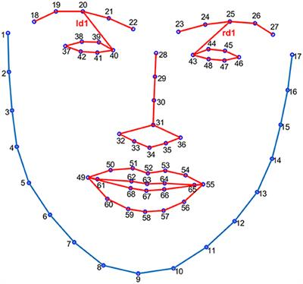

Fig 4. Open or closed eyes and lips are indicated by facial landmarks.

D. Feature Examination:

The features that are extracted can undergo further processing, including techniques for detecting yawning based on mouth movements or analyzing ocular features such as PERCLOS or EAR.

E. Classification:

Classifiers are employed in the classification system to access a driver's degree of tiredness. When the classifier identifies the signs of drowsiness regarding weighted parameters, an alert will be triggered, advising the driver to take a break. Developmental techniques have several drawbacks because of how illumination, camera movement, and the frame rate at which the driver's face is captured in a picture impact how well they work. Infrared (IR) cameras may frequently help to reduce illumination variations.

F. Eye detection module and Face ROI detection:

We utilize Viola-Jones Haar feature-based Cascade Classifiers [6] for confront discovery. We initially locate the Region of Interest (ROI) that contains the face to reduce false positives. We next proceed to use capturing eyes within this ROI, resulting in a rectangular localized area that has two eyes. Once the face and eyes were identified, we initiate tracking using CAMShift to follow their movement.

G. LSTM:

The challenge in identifying drowsiness lies in the difficulty of distinguishing between blinking and falling asleep based on a single frame. To address this challenge, we introduce our Conv-LSTM approach, which consists of two sub models: a CNN module to extract features and an LSTM module for explaining these features over successive frames. The following is how the laziness detection approach works: To begin with, we extricate noteworthy CNN highlights relative to video outlines. Subsequently, characteristics illustrating the activity (such as Alarm) over a specific time are inputted into the LSTM. Lastly, a SoftMax layer is employed to forecast how sleepy the whole video sequence is. Fig 1 depicts how our method works.

H. Module utilizing Convolutional Neural Network architecture (Inception-v3):

A dataset of images was manually constructed to extract features. A total of 18,000 photos were used to create two classes: Alert-Eyes and Drowsy-Eyes. We utilize convolutional neural networks (CNNs), the leading technology in image classification and feature extraction, to identify important visual elements in these pictures. We modified a pre-trained model called Inception-v3 [12] for the Large-Scale Visual Recognition Challenge (2012) [10]. This model was trained using the Image-Net dataset, which has 1000 classes. By employing transfer learning and TensorFlow, we retrained the model's last layer on the dataset [11]. Our exhibit revealed exactness of 96.5% on the approval set after 4000 preparatory actions. Next, we used the Inception model to process each frame (picture) in each movie, and the output of the last pooling layer (pool-3:0) was stored. We then passed this 2048-dimensional feature vector into the neural models that came next. Lastly, we group those traits that were retrieved into sequences.

I. Recurrent Neural Networks with Long Short-Term Memory (LSTM) units:

A unique class of RNN called LSTM can learn durable reliance without experiencing the disappearing and ballooning gradients issues. Each memory block consists of three components: recurrently connected memory cells and input, output, and forget gates, which control how information moves within the block. For visual time series problems, prediction (textual description) is made possible by the LSTM framework. The sequential model for detecting drowsy drivers is trained using concatenated features (16 movies x 26 frames x 1024 feature vectors). We used a 4096-width LSTM layer first, followed by 1024 dense layers with several dropout layers. Additionally, the demonstration for 100 ages with a group estimate of four, utilizing Keras and TensorFlow get prepared [21]. Then, utilized Adam Optimizer arranged with 0.00005 learning rate to prepare and improve the arranged weights.

EXPERIMENTAL RESULT

Insights gained by using recurrent neural networks with the LSTM module to extract findings are discussed in detail in this part, along with the procedure for gathering data.

Collection of Data:

The dataset comprises videos recorded featuring various types of drivers in both drowsy and active states. Many images are required for CNN training to ensure neural networks are well-trained. To accommodate this, instead of capturing individual photos, frames from the videos were extracted. These video frames were then manually labeled as either active or drowsy. Subsequently, the tagged images were split into training and testing sets for CNN training, following the procedure outlined in section III-G, which was used to extract information about the mouth and eyelids.

We spent around 10 minutes filming each of the about 30 drivers we had in mind. When recordings are activated, the first few minutes are finished. To further enhance the realism of the photographs, we have gathered the sleepy pictures right before they go to bed. It is not feasible to obtain precise photos of sleepiness, though. Every picture is captured at 30 frames per second. This means that there would be a total of 30 ∗ 60 ∗ 10, or 18,000 photos, in the dataset. Of which 12,600, or 70%, are utilized for training, while the remaining 5,400 photos are used for validation and testing.

B. Analyzing Results:

Detecting driver drowsiness is both fundamentally important and challenging. The observations and algorithms devised to assess driver drowsiness using LSTM is illustrated. The dataset details get covered in section IV-A. Training is conducted using labeled data and pertinent feature information, effectively training the model. Test results that are not labeled are given; the prepared demonstration must be used to bolster these results. The preparation gets done with adequate ages and gotten the misfortune and exactness details after each age. The testing data is then supplied when the framework has been suitably trained. Fig 5 provides an in-depth perspective of the suggested RNN-LSTM model for detecting driver sleepiness. The task of detecting tiredness in driver is treated as a binary classification task. It is necessary to extract a set of data points at regular intervals to evaluate the driver's degree of tiredness. Here, we have retrieved the relevant data for each 10ms interval. Thus, a model developed follows a many-to-one structure. Illustrating the suggested LSTM model to identify the driver's drowsiness state, which is considered a key component of this study in Fig 6.
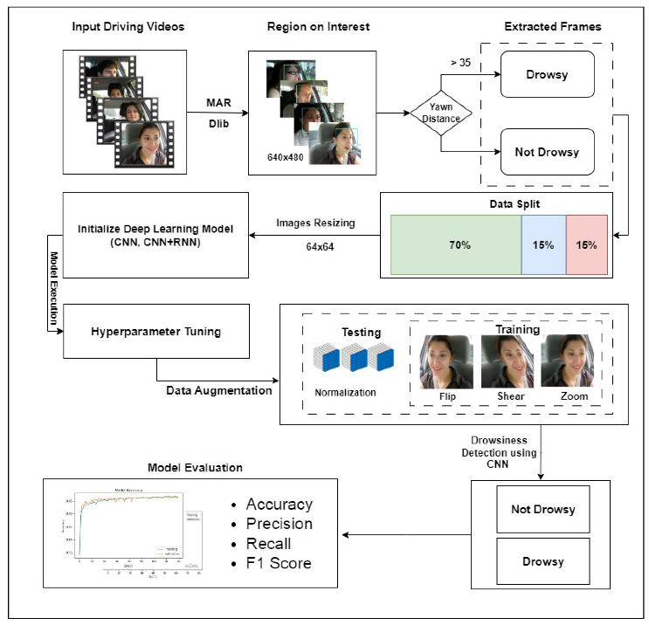

Fig. 5. The Deep Convolutional Neural Network Model for Detecting Driver Drowsiness

Prior to being fed into the LSTM model, the input values required scaling and normalization, necessitating preprocessing operations. Using the min-max normalization approach, we scaled all values between 0 and 1. The input data is usually transformed linearly using this approach. To standardize the output data, we also developed post-processing methods. Generally, the results get outputed through a SoftMax layer after being processed by the activation function. Due to the exponential nature of the activation function, there may be significant disparities from the results. In order to guarantee that the total of all output values stays equal and to match the input values with the output values, post-processing normalization was used.

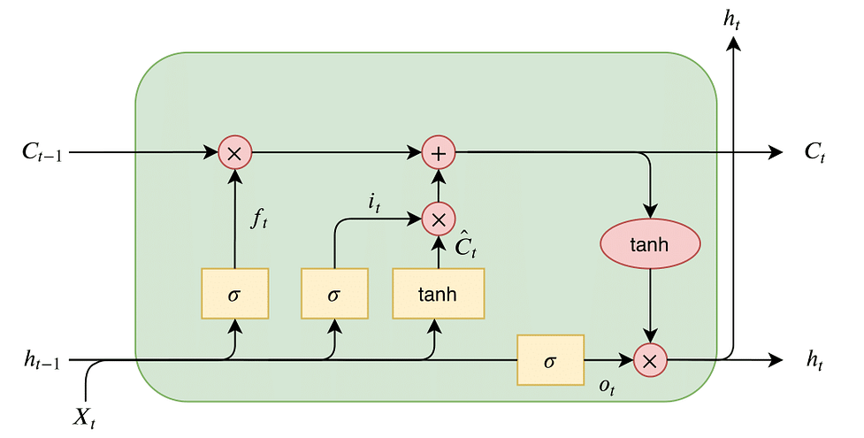

Fig. 6. Input-Output Selection for LSTM

Additionally, all the face data shown in Fig. 4, eye parameters, yawning frequency, and other information gleaned from lane analysis and vehicle control are used to train the LSTM model. These parameters are fed into the LSTM to train and evaluate the model. After post-processing normalization, the probability value indicates the degree of alertness or sleepiness. Approximately 97.20% accuracy is attained by the suggested technique with a very modest number of epochs—roughly 55. Figs. 7 and 8 show the specifics of the test and validation accuracy along with test and validation losses.

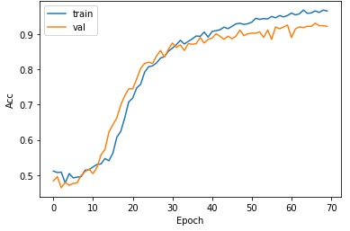Fig. 7. Training and validation accuracy in LSTM
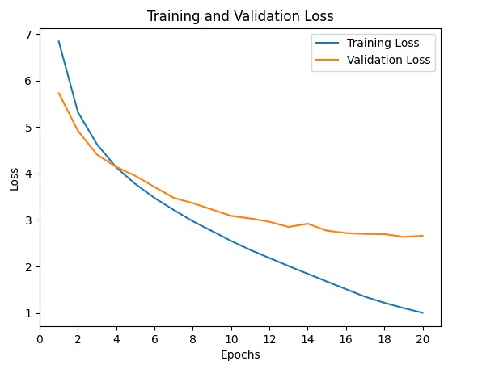
Fig. 8. Training and validation loss in LSTM

CONCLUSION AND FUTURE WORK

The area of drowsiness identification has grown as a prominent application, especially given the significant number of accidents attributed to drowsy driving. Traditional feature-based methods often fall short in effectively identifying drowsiness from nonlinear data obtained from facial, vehicle control, and lane parameters. Recently, deep neural networks have gained considerable traction. However, convolutional neural networks have surpassed the accuracy of many existing image processing applications. To handle temporal data effectively, RNNs with LSTM have been introduced. We observed that RNNs with LSTM outperform other feature-based methods in predicting or classifying periodic data.

A particular collection of characteristics for identifying driver tiredness has been established by this study. Future research will expand on this by incorporating long-term analysis of various factors, also with sleep patterns. Furthermore, future research will concentrate on integrating sleep, facial, and lane analysis using the emerging Internet of Things (IoT) technology. By leveraging the collected data from these characteristics and injecting it into effective deep neural networks with optimized parameters, we aim to enhance the accuracy of driver drowsiness detection. Additionally, our efforts are directed towards creating an application for entry-level to mid-range cars.

REFERENCES

[1] K. Fagerberg, “Vehicle-based detection of inattentive driving for integration in an adaptive lane departure warning system–drowsiness detection,” Master of Science Thesis,(Master thesis IR-SB-EX-0413),
Stockholm, Sweden, 2004.

[2] J. Krajewski, D. Sommer, U. Trutschel, D. Edwards, and M. Golz, “Steering wheel behavior based estimation of fatigue,” 2009.

[3] S. Kaplan, M. A. Guvensan, A. G. Yavuz, and Y. Karalurt, “Driver behavior analysis for safe driving: A survey,” IEEE Transactions on Intelligent Transportation Systems, vol. 16, no. 6, pp. 3017–3032, 2015.

[4] A. Sahayadhas, K. Sundaraj, and M. Murugappan, “Detecting driver drowsiness based on sensors: a review,” Sensors, vol. 12, no. 12, pp.16 937–16 953, 2012.

[5] Z. Mardi, S. N. M. Ashtiani, and M. Mikaili, “Eeg-based drowsiness detection for safe driving using chaotic features and statistical tests,” Journal of medical signals and sensors, vol. 1, no. 2, p. 130, 2011.

[6] E. Vural, M. C¸ etin, A. Erc¸il, G. Littlewort, M. Bartlett, and J. Movellan, “Machine learning systems for detecting driver drowsiness,” in Invehicle corpus and signal processing for driver behavior. Springer, 2009, pp. 97–110.

[7] M. J. Flores, J. M. Armingol, and A. de la Escalera, “Real-time warning system for driver drowsiness detection using visual information,” Journal of Intelligent & Robotic Systems, vol. 59, no. 2, pp. 103–125, 2010.

[8] T. Danisman, I. M. Bilasco, C. Djeraba, and N. Ihaddadene, “Drowsy driver detection system using eye blink patterns,” in International Conference on Machine and Web Intelligence. IEEE, 2010, pp. 230–233.

[9] B. Hariri, S. Abtahi, S. Shirmohammadi, and L. Martel, “A yawning measurement method to detect driver drowsiness,” Technical Papers, 2012.

[10] M. Jones and P. Viola, “Fast multi-view face detection,” Mitsubishi Electric Research Lab TR-20003-96, vol. 3, no. 14, p. 2, 2003.

[11] K. He, X. Zhang, S. Ren, and J. Sun, “Deep residual learning for image recognition,” in Proceedings of the IEEE conference on computer vision and pattern recognition, 2016, pp. 770–778.

[12] J. Jo, S. J. Lee, K. R. Park, I.-J. Kim, and J. Kim, “Detecting driver drowsiness using feature-level fusion and user-specific classification,” Expert Systems with Applications, vol. 41, no. 4, pp. 1139–1152, 2014.

[13] M. S. Devi, M. V. Choudhari, and P. Bajaj, “Driver drowsiness detection using skin color algorithm and circular hough transform,” in 2011 Fourth International Conference on Emerging Trends in Engineering & Technology. IEEE, 2011, pp. 129–134.

[14] M. Awais, N. Badruddin, and M. Drieberg, “A hybrid approach to detect driver drowsiness utilizing physiological signals to improve system performance and wearability,” Sensors, vol. 17, no. 9, p. 1991, 2017.

[15] J. Long, E. Shelhamer, and T. Darrell, “Fully convolutional networks for semantic segmentation,” in Proceedings of the IEEE conference on computer vision and pattern recognition, 2015, pp. 3431–3440.

[16] A. Krizhevsky, I. Sutskever, and G. E. Hinton, “Imagenet classification with deep convolutional neural networks,” in Advances in neural information processing systems, 2012, pp. 1097–1105.

[17] O. M. Parkhi, A. Vedaldi, A. Zisserman et al., “Deep face recognition.” in 26th British Machine Vision Conference, vol. 1, no. 3, 2015, p. 6.

[18] J. Donahue, L. Anne Hendricks, S. Guadarrama, M. Rohrbach, S. Venugopalan, K. Saenko, and T. Darrell, “Long-term recurrent convolutional networks for visual recognition and description,” in Proceedings of the IEEE conference on computer vision and pattern recognition, 2015, pp. 2625–2634.

[19] K. Dwivedi, K. Biswaranjan, and A. Sethi, “Drowsy driver detection using representation learning,” in 2014 IEEE International Advance Computing Conference (IACC). IEEE, 2014, pp. 995–999.

[20] S. Park, F. Pan, S. Kang, and C. D. Yoo, “Driver drowsiness detection system based on feature representation learning using various deep networks,” in Asian Conference on Computer Vision. Springer, 2016, pp. 154–164.

[21] Y.V. Srinivasa Murthy, Koolagudi, Shashidhar, M .V. Manoj, Swapna Donepudi. (2020). “Driver Drowsiness Detection Using Facial Parameters and RNNs with LSTM”, 1-7. 10.1109/INDICON49873.2020.9342348.

